4G/AFS AFS Block - CYRS Component system requirements specification

Project : 30 AFS Master ECU Requirements
Version: 3.6 (Valid)

0000.doc

 | Name | Function | Date | Visa
Written By | marc.bis | SEL | 09 August 2013
Approved By |  | PM
Approved By |  | SDL
Approved By |  | STSL
Approved By |  | SQO

Document History
Version | Date | Modified by | Comments
3.1 Valid | 9/12/2011 | joel.li | Update after correction (Action plan and setting)
3.2 Valid | 31/1/2012 | joel.li | Simplification of the state machine  Addition of new upper state
3.3 Valid | 21/3/2012 | joel.li | Definition of the periodicity of the functions
3.4 proposed | 28/6/2012 | marc.bis | Replacement of pseudo code by text concerning the detection of road
3.5 proposed | 21/12/2012 | patrick.lacombe | Update Projet attribute
3.6 Valid | 9/8/2013 | marc.bis | update with remarks done during the last review with SW team in 18/02/2013, concerns only minor corrections.

Configuration Module :

Parameters | Values
Type Document | CYRS
Name view | 91 - STD Word Export
Filter | Active

Table of Content

1. Introduction 5
1.1. Scope of the document 5
1.2. Documentation 5
1.3. Abreviations 5
1.4. System Overview 6
2. AFS block functional description 7
2.1. AFS block functional synoptic 7
2.2. Input / Output Datas 8
2.2.1. Input datas 8
2.2.2. Output datas 11
2.3. AFS functions control strategy description 12
2.3.1. AFS functional modes configuration chart 12
2.3.2. Functional description and control algorithms 13
2.3.3. AFS function internal parameters 23
2.3.4. AFS function internal variables 34
2.3.5. Fail safe strategy 37
2.3.6. Main operating state diagram 37
2.3.7. State transition synthesis chart 39

Introduction

Scope of the document
This document is part of the total AFS Lighting Control System “LCS 4G” board specification.
The main functions of the board are :
· Controlling up to six actuators on two LIN buses (three on each bus)
· Controlling 2 lamps (FBL or Cornering)
· Controlling 2 Trixenon modules
This ECU answers to most of the lighting function needs of the customers for AFS "Adaptive Front Lighting System" headlamps for 2010, that is controlling leveling, DBL, FBL, Motorway lighting, Town lighting, Tourist mode, Adverse weather and Cornering light, in accordance to the CAN communication interface; The document has been separated in several parts, due to its size.
This specification is valid for a 4G UCC board integrated or fixed in the motor compartment.

Documentation
The following is the Reference document list
Ref. | Identification | Title
0 | 2203-1101-000-F | LCS Project Référence List
1 | 2203-109-001 | AFS functional analisys
2 | 0503-210-310 | 4G/AFS LCS Master Standard ECU - CYRS specification
3 | 0503-210-320 | LVL Chassis Sensor Conditionner - CYRS specification
4 | 0503-210-322 | 4G/AFS Leveling Block - CYRS specification
5 | 0503-210-330 | DBL/3G Sensor Conditionner - CYRS specification
6 | 0503-210-332 | 4G/AFS DBL Block - CYRS Specification
7 | 0503-210-350 | 4G/AFS AFS Block - CYRS Specification
8 | 0503-210-380 | 4G/AFS LIN Bus Controller - CYRS specification
9 | 0503-210-381 | 4G/AFS LIN Bus Message Set - CYRS specification
10 | 0503-210-382 | 4G/AFS CAN Bus Message Set - CYRS specification
11 | 0503-210-385 | 4G/AFS DiagOnCAN - CYRS specification

Abreviations
Ref. | Identification | Title
 | AFS | Adaptive Front Lighting System or Advanced Front Lighting System
 | CAN | Controller Area Network
 | CRS | Component Requirement Specification
 | DBL | Dynamic Bending Light
 | DIAG | Diagnosis Functional Block
 | DL | Dynamic Leveling
 | DRL | Daytime Running Light
 | DTY | Duty Cycle
 | ECU | Electronic Control Unit
 | EDL | External Dynamic Leveler
 | FBL | Fixed Bending Light
 | GND | Electrical Ground
 | Req | Requirement
 | LCS | Light Control System
 | LIN | Local Interconnect Network
 | LVL | Leveling Functional Block
 | LSB | Least Significant Bit
 | OC | Open Circuit
 | RLB | Raised Low Beam
 | SCL | Speed Control Leveling
 | SC | Short Circuit
 | UID | Unique Identifier

System Overview
This document describes the AFS functional block, in charge of control the head lamp low beam position in accordance to the R123 regulation.
The main functions of this block are :
· Managing the TriXenon boards which is en charge of control the TriXenon module motor.
· Calculating the specific LVL and DBL modules offset positions
AFS system - LIN architecture synoptic
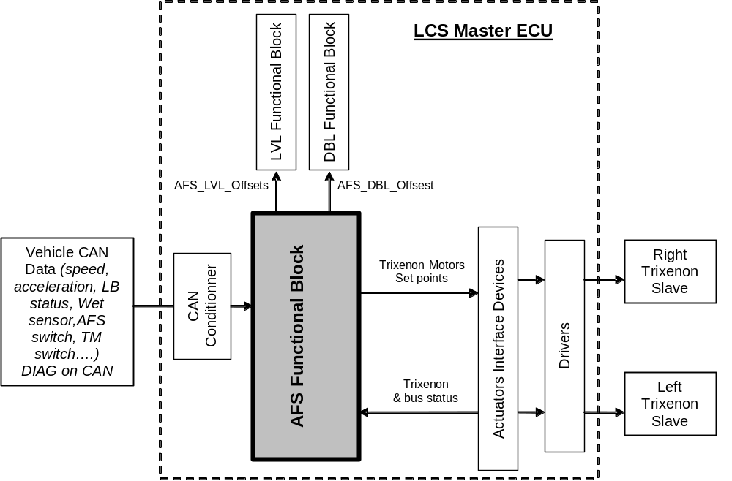
Figure 1 : AFS system architecture
In the following document, conventions applied comply with the LCS Reference List (Ref1).
An evolution sheet will be edited for all evolution or change requests.

AFS block functional description

AFS block functional synoptic
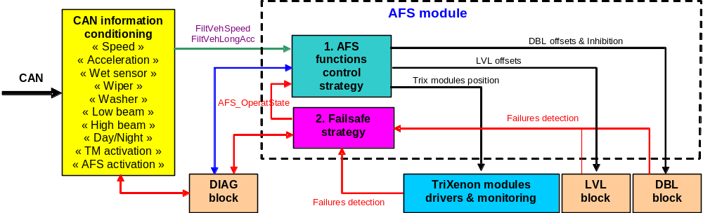

Figure 2 : AFS module functional synoptic

Input / Output Datas

Input datas
This chart lists all the input signals of the AFS fucntional block. It refers to the 4G LCS UCC board Synoptic technical specification "Ref: 7"
Req Tag | Allocation | Mnemonic | Description | Sampling | Unit | Min | Max | Resolution | Default value | Coding | Interface
Req_0503_CYRS_AFS_2933-V121221 | #SW  #System | LowBeamStatus | Low beam status | 100 ms | - | 0 | 1 | 1 | 0 | 0 = OFF  1 = ON | CAN
Req_0503_CYRS_AFS_2932-V121221 | #SW  #System | HighBeamStatus | High beam status | 100 ms | - | 0 | 1 | 1 | 0 | 0 = OFF  1 = ON | CAN
Req_0503_CYRS_AFS_2931-V121221 | #SW  #System | DayNightStatus | Day Night status | 100 ms | - | 0 | 1 | 1 | 1 | 0 = Day  1 = Night | CAN
Req_0503_CYRS_AFS_2935-V121221 | #SW  #System | FiltVehSpeed | Filtered Vehicle speed | 20 ms | Km/h | 0 | 511.984375 | 0.0078125 | 0 | 0x0000 - 0xFFFE | CAN
Req_0503_CYRS_AFS_2936-V121221 | #SW  #System | FiltVehLongAcc | Filtered Longitudinal vehicle acceleration | 20 ms | m/s ² | -10.24 | +10.08 | 0.08 | 0 | 0x00 - 0xFE | CAN
Req_0503_CYRS_AFS_3551-V121221 | #SW  #System | WetSensorStatus | Wet sensor status. | 100 ms | - | 0 | 1 | 1 | 0 | 0 = Not Wet  1 = Wet | CAN
Req_0503_CYRS_AFS_3896-V121221 | #SW  #System | WiperStatus | Wiper activation status. | 100 ms | - | 0 | 1 | 1 | 0 | 0 = OFF  1 = ON | CAN
Req_0503_CYRS_AFS_3911-V121221 | #SW  #System | WprWashStatus | Wiper activation by washer request status. | 100 ms | - | 0 | 1 | 1 | 0 | 0 = OFF  1 = ON | CAN
Req_0503_CYRS_AFS_2937-V121221 | #SW  #System | TM_ActStatus | Tourist mode activation status | 100 ms | - | 0 | 1 | 1 | 0 | 0 = OFF  1 = ON | CAN
Req_0503_CYRS_AFS_2941-V121221 | #SW  #System | AFS_ActStatus | AFS function activation status | 100 ms | - | 0 | 1 | 1 | 1 | 0 = OFF  1 = ON | CAN
Req_0503_CYRS_AFS_4000-V121221 | #SW | Trix_RightOV | Right Trixenon module power supply over voltage status | Event | - | 0 | 1 | 1 | 0 | 0 = No failure  1 = Failure | AIMD
Req_0503_CYRS_AFS_3999-V121221 | #SW | Trix_LeftOV | Left Trixenon module power supply over voltage status | Event | - | 0 | 1 | 1 | 0 | 0 = No failure  1 = Failure | AIMD
Req_0503_CYRS_AFS_3998-V121221 | #SW | Trix_RightUV | Right Trixenon module power supply under voltage status | Event | - | 0 | 1 | 1 | 0 | 0 = No failure  1 = Failure | AIMD
Req_0503_CYRS_AFS_3997-V121221 | #SW | Trix_LeftUV | Left Trixenon module power supply under voltage status | Event | - | 0 | 1 | 1 | 0 | 0 = No failure  1 = Failure | AIMD
Req_0503_CYRS_AFS_2949-V121221 | #SW | Trix_RightFail | Right Trixenon module fail : motor or internal electronic board failures  Right "Trix_ElDef" = 1 OR Right "Trix_Board_Fail" = 1 | Event | - | 0 | 1 | 1 | 0 | 0 = No failure  1 = Failure | AIMD
Req_0503_CYRS_AFS_2948-V121221 | #SW | Trix_LeftFail | Left Trixenon module fail : motor or internal electronic board failures  Left "Trix_ElDef" = 1 OR Left "Trix_Board_Fail" = 1 | Event | - | 0 | 1 | 1 | 0 | 0 = No failure  1 = Failure | AIMD
Req_0503_CYRS_AFS_2957-V121221 | #SW | Trix_RightComFail | Right Trixenon bus communication failure | Event | - | 0 | 1 | 1 | 0 | 0 = No failure  1 = Failure | AIMD
Req_0503_CYRS_AFS_2956-V121221 | #SW | Trix_LeftComFail | Left Trixenon bus communication failure | Event | - | 0 | 1 | 1 | 0 | 0 = No failure  1 = Failure | AIMD
Req_0503_CYRS_AFS_2950-V121221 | #SW | DBL_RightDBL_Failsafe | Right DBL state in failsafe mode | Event | - | 0 | 1 | 1 | 0 | 0 = No failure  1 = Failure | DBL
Req_0503_CYRS_AFS_2951-V121221 | #SW | DBL_LeftDBL_Failsafe | Left DBL state in failsafe mode | Event | - | 0 | 1 | 1 | 0 | 0 = No failure  1 = Failure | DBL
Req_0503_CYRS_AFS_3513-V121221 | #SW | LVL_RightFail | Right LVL state in failsafe mode | Event | - | 0 | 1 | 1 | 0 | 0 = No failure  1 = Failure | LVL
Req_0503_CYRS_AFS_3512-V121221 | #SW | LVL_LeftFail | Left LVL state in failsafe mode | Event | - | 0 | 1 | 1 | 0 | 0 = No failure  1 = Failure | LVL
Req_0503_CYRS_AFS_2962-V121221 | #SW  #System | CAN_Fail | CAN communication failure | Event | - | 0 | 1 | 1 | 0 | 0 = No failure  1 = Failure | CAN  Supervisor
Req_0503_CYRS_AFS_4017-V121221 | #SW | BoardActStatus | Board activation status | Event | - | 0 | 7 | 1 | 0 | 0 = Desactivated  1 = Start  2 = Initisation  3 = Flash  4 = Bist  5 = Active  6 = Diag  7 = Failled | Supervisor

Output datas
This chart lists all the output signals of the AFS fucntional block. . It refers to the 4G LCS UCC board Synoptic technical specification "Ref: 7"
Req Tag | Allocation | Mnemonic | Description | Sampling | Unit | Min | Max | Resolution | Default value | Coding | Interface
Req_0503_CYRS_AFS_2969-V121221 | #SW  #System | AFS_Trix_LeftSetPos | Left Trix motor set point position | 20 ms | - | 0 | 3 | 1 | 0 | 0 = No position active  1 = LB active  2 = ML active  3 = HB active | AIMD
Req_0503_CYRS_AFS_2970-V121221 | #SW  #System | AFS_Trix_RightSetPos | Right Trix motor set point position | 20 ms | - | 0 | 3 | 1 | 0 | 0 = No position active  1 = LB active  2 = ML active  3 = HB active | AIMD
Req_0503_CYRS_AFS_3507-V121221 | #SW  #System | AFS_LVL_LeftOffset | AFS LVL offset position (Attitude %rad) for the Left Head Lamp | 20 ms | %rad | -5 | +5 | 0.001 | 0 |  | LVL
Req_0503_CYRS_AFS_3508-V121221 | #SW  #System | AFS_LVL_RightOffset | AFS LVL offset position (Attitude %rad) for the Right Head Lamp | 20 ms | %rad | -5 | +5 | 0.001 | 0 |  | LVL
Req_0503_CYRS_AFS_3509-V121221 | #SW  #System | AFS_DBL_LeftOffset | AFS DBL offset position (Degres) for the Left Head Lamp | 20 ms | ° | -12.5 | +12.5 | 0.1 | 0 | 0x00 - 0xFF | DBL
Req_0503_CYRS_AFS_3510-V121221 | #SW  #System | AFS_DBL_RightOffset | AFS DBL offset position (Degres) for the Right Head Lamp | 20 ms | ° | -12.5 | +12.5 | 0.1 | 0 | 0x00 - 0xFF | DBL
Req_0503_CYRS_AFS_3880-V121221 | #SW  #System | AFS_DBL_Inhib | Inhibition of the DBL set point calculation in the 0° value | 20 ms | - | 0 | 1 | 1 | 0 | 0 -> DBL not Inhibited  1 -> DBL Inhibited | DBL
Req_0503_CYRS_AFS_4001-V121221 | #SW | AFS_Fail | AFS function failed | Event | - | 0 | 1 | 1 | 0 | 0 = No failure  1 = Failure | Diag

AFS functions control strategy description
The AFS module is made up of 10 main functional modes corresponding to the different AFS "class and modes" of the Low Beam and High Beam functions . They act dynamically on the headlamp Trixenon module, LVL module and DBL module.
These functions are independent and so can be separated and be selected (enabled) by a diagnostic service "AFS_FunctConf" . (refer to Diag services for Dynamic 4G LCS)

AFS functional modes configuration chart
Req_0503_CYRS_AFS_2999-V130531
#SW
#System
The different functional modes of AFS function can be configurated (enabled) via the "AFS_FunctConf" parameter. This parameter is programmed in EEPROM and modifiable by a diagnosis service.

The following table gives the various configurations available for the AFS sub-functions activation.
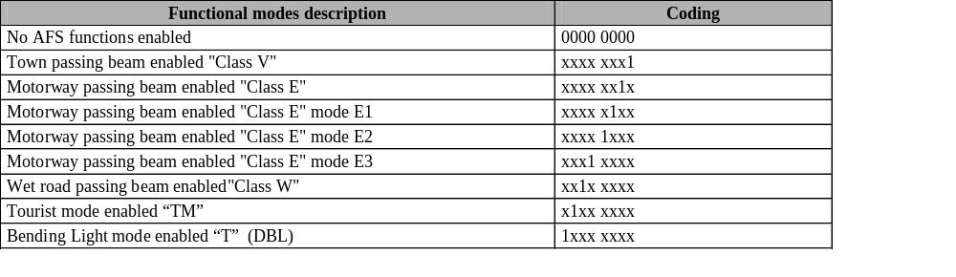
Req_0503_CYRS_AFS_3825-V121221
#SW
#System
The configuration by default is : (0000 0000) "No AFS functions enabled". See paragraph : "AFS function internal parameters".

Functional description and control algorithms
Req_0503_CYRS_AFS_3114-V121221
#SW
#System
AFS function will be activated or not depending on the state of the "AFS_ActStatus" and "TM_ActStatus" input variables. If the function isn’t active the output values will be set to "0" No Functions selected and the defect management will not be taken into account.

AFS control algorithms synoptic
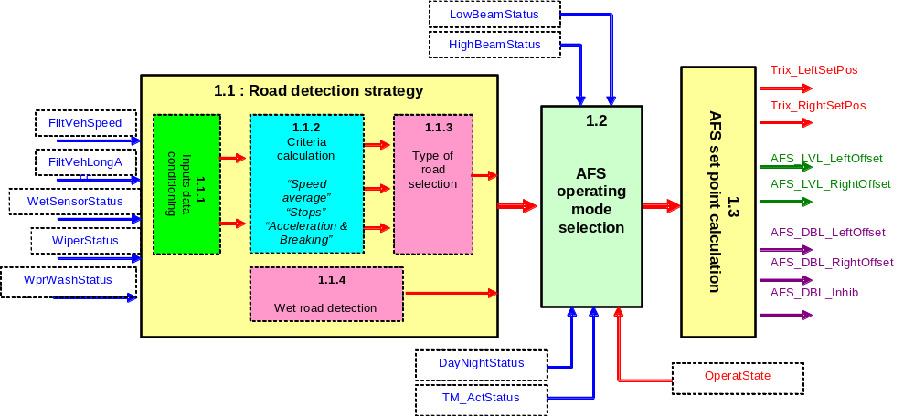

Figure 3 : AFS function synoptic

Block 1.1 : Road detection strategy
To have a right functionality for the different functional blocks, the sequence of the following calculations need to be respected.

Block 1.1.1 : Inputs data conditioning
The periodicity of this block is set to 20 ms.
These signals are calculated by the CAN interface block ( Filtered Vehicle speed and Filtered Longitudinal Acceleration calculation ). See variables desciption on "Ref : 2" document list specification and see paragraph " Vehicle speed filtering and Longitudinal Acceleration calculation"

Block 1.1.2 : Vehicle criterias calculation
The specific criterias are calculated with the signals "FiltVehSpeed" and "FiltVehLongAcc" inputs to allow a selection the type of road.
Req_0503_CYRS_AFS_4024-V121221
#SW
The periodicity of this block is set to 20 ms for "Vehicle stops counter" and "Vehicle acceleration counter" and set to 1 s for "Vehicle speed average calculation".
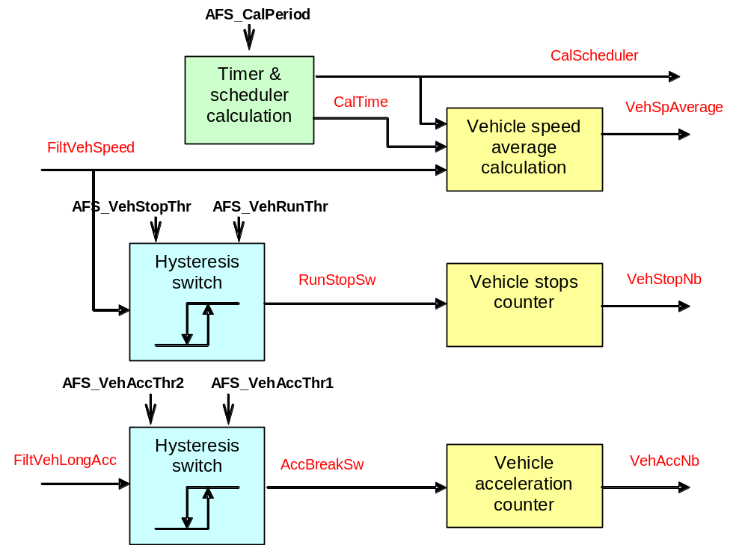

Figure 5 : Main criteria calculation synoptic
Req_0503_CYRS_AFS_3746-V130809
#SW
CalTime & Scheduler calculations :

If (CalTime >= AFS_CalPeriod)
CalScheduler = 0
Else
CalScheduler = 1
Inc CalTime
End If

Req_0503_CYRS_AFS_3755-V130809
#SW
Vehicle speed average calculation :

If CalScheduler == 1
VehSpeedAdd = VehSpeedAdd ₋₁ + VehSpeed_f
VehSpAverage = VehSpeedAdd / (CalTime/1 s)
End If

Req_0503_CYRS_AFS_3753-V130218
#SW
Run/Stop hysteresis switch calculation :

The Run and Stop states which depend of filtering speed vehicle (FiltVehSpeed ) follow a hysteresis with AFS_VehRunThr value to pass to Run state and with AFS_VehStopThr to pass to STOP state.

Req_0503_CYRS_AFS_3754-V121221
#SW
Vehicle stop counter :

The stop counter is incremented at each phase Run then stop

Req_0503_CYRS_AFS_3748-V130218
#SW
Acceleration hysteresis switch calculation :

The states Acceleration and Breaking which depend of filtering vehicle acceleration (FiltVehLongAcc) follow a hysteresis with AFS_VehAccThr1 value to pass to Acceleration state and with AFS_VehAccThr2 to pass to breaking state.

Req_0503_CYRS_AFS_3752-V130218
#SW
Vehicle acceleration/Breakings counter :

The vehicle acceleration/breaking counter is incremented at each phase Acceleration then Breaking

Block 1.1.3 : Type of road selection
The type of road is calculed and selected according to the specific criterias and parameters
Req_0503_CYRS_AFS_4025-V121221
#SW
The periodicity of this block is set to 20 ms for "Type of road Calculation" and set to 1s for "Type of road Selection"
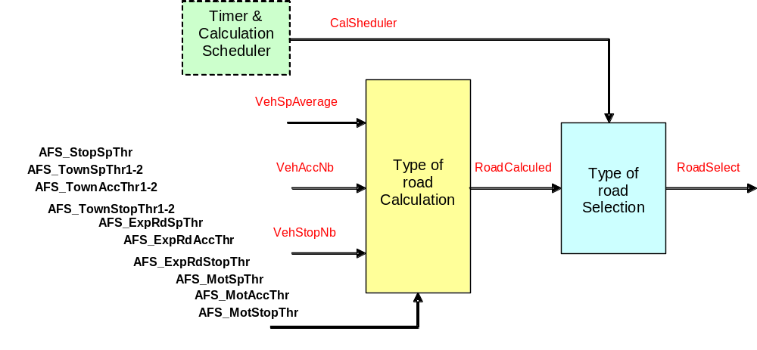

Figure 6 : Type of road selection synoptic
Req_0503_CYRS_AFS_3799-V130531
#SW
Type of road calculation table :
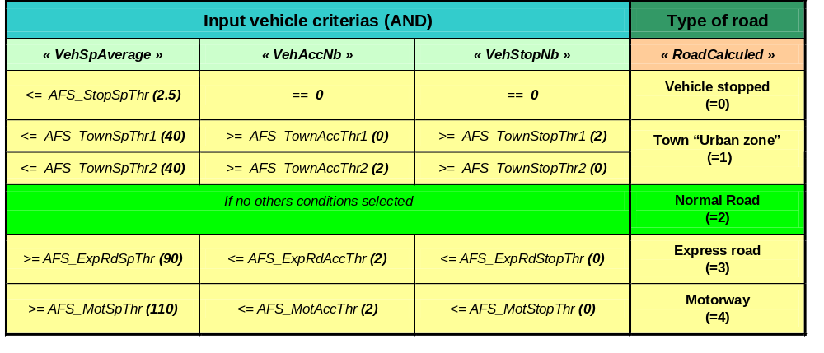
Figure 7 : Type of road calculation criterias
Req_0503_CYRS_AFS_3800-V130531
#SW
Type of road selection :

At each time the timer (CalTime) passes the AFS_CalPeriod reference, the type of road is available with fig 7 and the cycle of road calculation is relaunched.

Block 1.1.4 : Wet road detection
The wet road detection "WetDetect" variable is calculated with the "WetSensorStatus" or the "WiperStatus & WprWashStatus" signals.
To implement the AFS Adverse Weather function "W class", at least one of this "set" signals shall be available on CAN bus.
Req_0503_CYRS_AFS_4027-V121221
#SW
The periodicity of this block is set to 1 s.
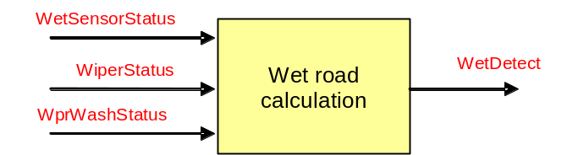

Figure 8 : Wet road calculation synoptic
Req_0503_CYRS_AFS_3900-V121221
#SW
#System
Wet road calculation :
If (WetSensorStatus ==1)
WetDetect ==1
Else
If (WetDetect ==0)
If (WiperStatus ==1 & WprWashStatus ==0 & CounterWash ==0)
Inc CounterWprOn
Else
If ((WprWashStatus ==1 || CounterWash >0) & CounterWprOn <=10s)
Inc CounterWash
Reset CounterWprOn
If (CounterWash >=10s)
Reset CounterWash
End If
End If
End If
If (WiperStatus ==0 & CounterWprOn >0 & CounterWprOff < 255)
Inc CounterWprOff
End If
If (WiperStatus ==1 & CounterWprOn + CounterWprOff >= 120s)
If (CounterWprOff <120s)
WetDetect ==1
Reset CounterWprOn
Reset CounterWprOff
Else
Reset CounterWprOn
Reset CounterWprOff
End If
End If
Else
If (WiperStatus ==0)
Inc CounterWprOff
Else
Reset CounterWprOff
End If
If (CounterWprOff >=240s)
WetDetect ==0
Reset CounterWprOff
End If
End If
End If

Block 1.2 : AFS functional modes selection
AFS functional modes (functions) are selected according to various criteria : Low beam and High beam status, Vehicle speed, Wet road status, Day/Night status, Tourist Mode status, Type of the road and the AFS function configuration.
« AFS_FunctSelect » is a variable defining the functional mode selected of the AFS function. The criteria are «LowBeamStatus», «HighBeamStatus», «DayNightStatus», «TM_ActStatus», «WetRoadStatus», «VehicleSpeed», «AFS_FunctConf», «RoadSelect».
« For a physical definition of each data, refer to the internal parameter feature chart in chapter §2.2.1- Input datas, §2.2.2-Output datas and to the internal variable feature chart in chapter §2.3.4»
Two types of selection criterias of functional modes are possible: "Dynamic selection mode" operate mainly with vehicle speed criteria. "Adaptatif selection mode" operate with vehicle speed data and the type of road detection.
Req_0503_CYRS_AFS_3878-V121221
#SW
#System
The type of selection of functional modes is configurable through the "AFS_SelectCritConf" parameter and modified by Diag sevice. By default the "Adaptatif functional mode" is configured.

Functional modes selection diagram
AFS classes and functional modes of the Low beam function allowed by type of the road detected and in function of the vehicle speed
Req_0503_CYRS_AFS_3796-V121221
#SW
#System
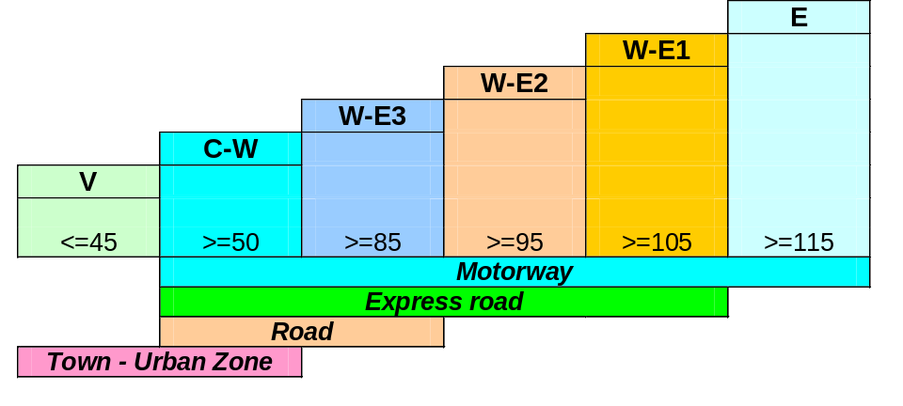

Figure 9 : AFS class and functional modes allowed by type of road detected
Req_0503_CYRS_AFS_3548-V121221
#SW
#System
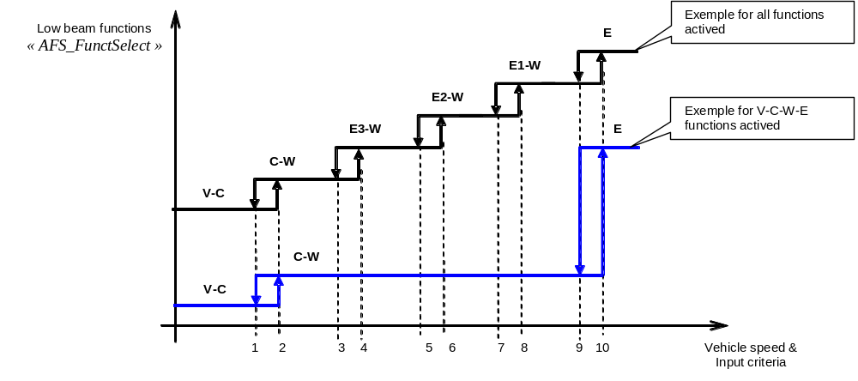

Figure 10 : AFS Low Beam functional mode selection diagram

Req_0503_CYRS_AFS_3879-V121221
#SW
#System
When activated, the class W has priority over class C and E1 and E2 and E3.
On motorways, in the case of classes E and W are activated and selected the class E has priority.

Criterias of adaptive functional mode selection
This table lists all the input conditions for the adaptive functional mode selection of the AFS fucntional block.
Req_0503_CYRS_AFS_3543-V130531
#SW
#System
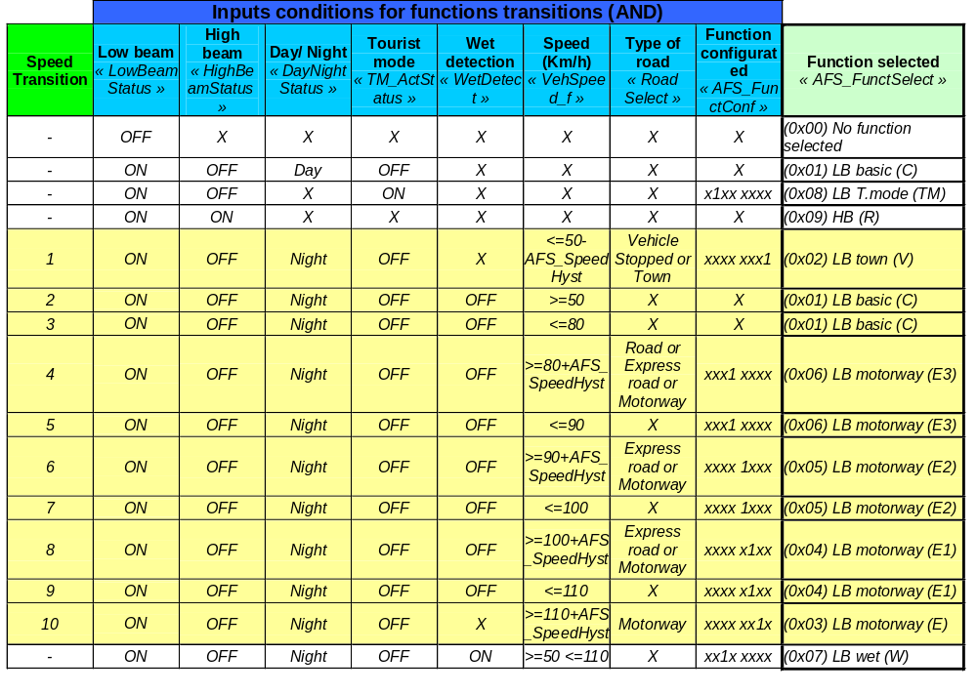

Figure 11 : Adaptive functional mode selection criterias

Criterias of dynamic functional mode selection
This table lists all the input conditions for the dynamic functional mode selection of the AFS fucntional block.
Req_0503_CYRS_AFS_3873-V121221
#SW
#System
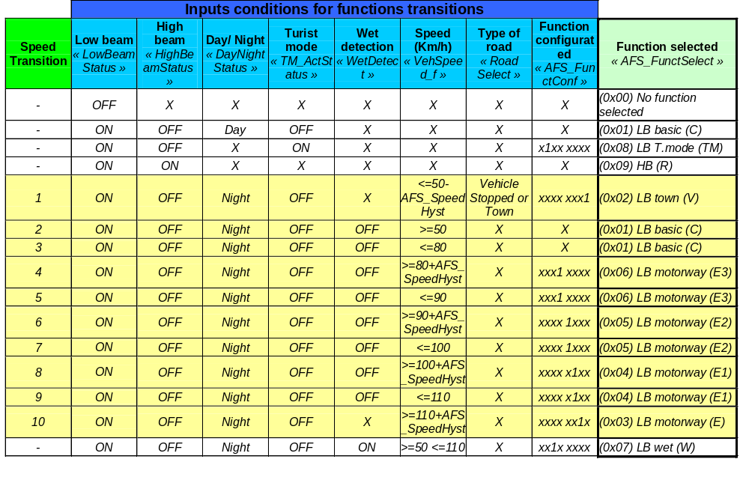

Figure 12 : Dynamic functional mode selection criterias
Req_0503_CYRS_AFS_3875-V130218
#SW
When a functional mode "functions AFS" has been selected the system keeps this state until another mode has been validated.

Priority Methodology of functional mode
The diagram above shows the priority levels of functions. Whatever the selected class, the strategy AFS continues to be calculated even if it is inhibited by another higher priority function or class (W, TM, HB) and ensure the return to a proper class AFS at the next activation.
If no function selected, The default function is LB basic (C).

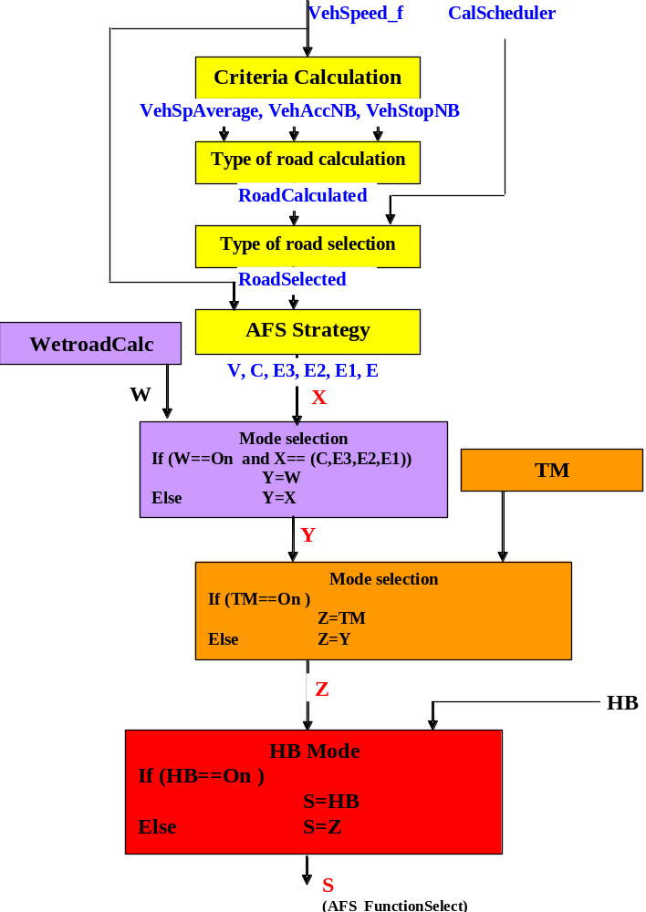

Safety operating mode selection
The operating modes selection are depending on the failsafe strategy and a specific functional mode is selected for each operating state. "See chapter : Fail safe strategy".
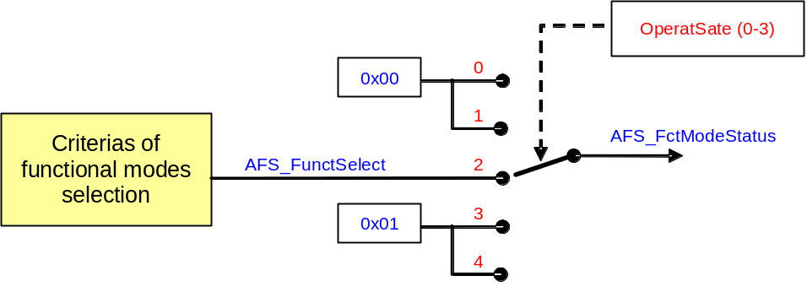

Figure 13 : Safety functional mode selection
Req_0503_CYRS_AFS_3908-V121221
#SW
#System
At power ON (Start) or if the AFS is not actived "AFS_OperatState=0", the "AFS_FctModeStatus" need to be set to 0x00.
Req_0503_CYRS_AFS_3974-V121221
#SW
#System
For the state (Init system) "AFS_OperatState=1", the "AFS_FctModeStatus" need to be set to 0x00.
Req_0503_CYRS_AFS_3975-V121221
#SW
#System
For the state (AFS function active) "AFS_OperatState=2", the "AFS_FctModeStatus" need to be set with the "AFS_FunctSelect" value.
Req_0503_CYRS_AFS_3972-V121221
#SW
#System
In case of failures the AFS system go to the (AFS safety) operating state "AFS_OperatState=3" or "AFS_OperatState=4". A faisafe AFS function "LB basic (C)" (0x01) need to be set in "AFS_FctModeStatus".

Block 1.3 : AFS set points calculation
This table lists the set point values for the Trixenon, LVL and DBL actuators for each AFS functional mode selected. The corresponding parameters are implemented in the EEPROM and can be modified by Diag.
Signs convention of the offset values : LVL to down = (-X), LVL to high = (+X), DBL to left = (-X), DBL to right = (+X)
Req_0503_CYRS_AFS_3544-V121221
#SW
#System
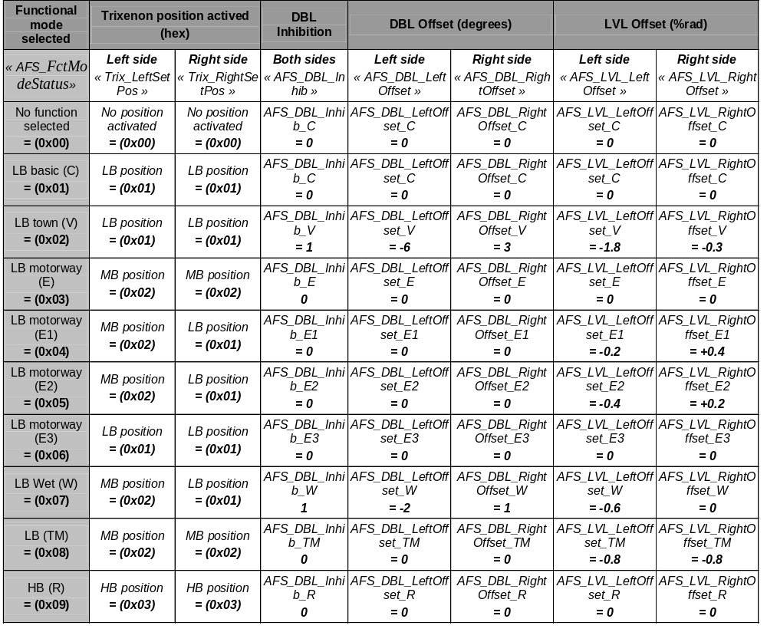

Figure 14 : AFS modes and functions set points table
Req_0503_CYRS_AFS_3895-V121221
#SW
#System
The values of this table correspond to a vehicle for a Right hand trafic. For the left hand trafic, symetrical values for offset need to be implemented. (The values of column Right side become values of column Left side and the values of column Left side become values of column Right side)

AFS function internal parameters
Req_0503_CYRS_AFS_3350-V130809
#SW
#System
The following paramters shall be stored in EEPROM and accessed via Diag On CAN resquests. Refer to "Ref : 11" document list : 4G/AFS DiagOnCAN - CYRS specification

Req_0503_CYRS_AFS_3917-V121221
#SW
#System
Any modification of the following parameters leads automatically the reset of the flag "AFS_ConfStatus". After the configuration is done "AFS_ConfStatus" shall be set to 1.
Req Tag | Allocation | Mnemonic | Description | Sampling | Unit | Min | Max | Resolution | Default value | Coding | Interface
Req_0503_CYRS_AFS_3804-V121221 | #SW  #System | AFS_FunctConf | AFS functional modes configuration. |  | - | 0x00 | 0xFF | 1 | 0x00 | See (2.3.1) AFS functional modes configuration chart | Diag
Req_0503_CYRS_AFS_3918-V121221 | #SW  #System | AFS_ConfStatus | AFS function configuration done status | - | - | 0 | 1 | 1 | 0 | 0 = Not done  1 = Done | Supervisor
Req_0503_CYRS_AFS_3876-V121221 | #SW  #System | AFS_SelectCritConf | Selection criterias configuration of AFS functional modes |  | - | 0 | 1 | 1 | 1 | 0 = Dynamic  1 = Adaptive | Diag
Req_0503_CYRS_AFS_3762-V121221 | #SW  #System | AFS_CalPeriod | Period for the calculation scheduler |  | s | 0 | 255 | 1 | 60 |  | Diag
Req_0503_CYRS_AFS_3362-V121221 | #SW  #System | AFS_VehRunThr | Vehicle speed threshold to switch on the "Vehicle Runing" mode |  | Km/h | 0 | 127.5 | 0.5 | 5 |  | Diag
Req_0503_CYRS_AFS_3766-V121221 | #SW  #System | AFS_VehStopThr | Vehicle speed threshold to switch off the Vehicle Runing" mode |  | Km/h | 0 | 127.5 | 0.5 | 2.5 |  | Diag
Req_0503_CYRS_AFS_3767-V121221 | #SW  #System | AFS_VehAccThr1 | Acceleration threshold to switch on the "Vehicle Acceleration or Braking" mode |  | m/s ² | 0 | +10,08 | 0.08 | 1 |  | Diag
Req_0503_CYRS_AFS_3768-V121221 | #SW  #System | AFS_VehAccThr2 | Acceleration threshold to switch off "Vehicle Acceleration or Braking mode" |  | m/s ² | 0 | +10.08 | 0.08 | 0.25 |  | Diag
Req_0503_CYRS_AFS_3811-V121221 | #SW  #System | AFS_StopSpThr | Speed average threshold to calcul the vehicle "stop state" in the "Type of road calculation" module |  | Km/h | 0 | 127.5 | 0.5 | 2.5 |  | Diag
Req_0503_CYRS_AFS_3814-V121221 | #SW  #System | AFS_TownSpThr1 | Speed average threshold to calcul the "town state" in the "Type of road calculation" module |  | Km/h | 0 | 127.5 | 0.5 | 40 |  | Diag
Req_0503_CYRS_AFS_3815-V121221 | #SW  #System | AFS_TownSpThr2 | Speed average threshold to calcul the "town state" in the "Type of road calculation" module |  | Km/h | 0 | 127.5 | 0.5 | 40 |  | Diag
Req_0503_CYRS_AFS_3817-V121221 | #SW  #System | AFS_TownAccThr1 | Number of accelerations threshold to calcul the "town state" in the "Type of road calculation" module |  | - | 0 | 255 | 1 | 0 |  | Diag
Req_0503_CYRS_AFS_3890-V121221 | #SW  #System | AFS_TownAccThr2 | Number of accelerations threshold to calcul the "town state" in the "Type of road calculation" module |  | - | 0 | 255 | 1 | 2 |  | Diag
Req_0503_CYRS_AFS_3819-V121221 | #SW  #System | AFS_TownStopThr1 | Number of stops threshold to calcul the "town state" in the "Type of road calculation" module |  | - | 0 | 255 | 1 | 2 |  | Diag
Req_0503_CYRS_AFS_3818-V121221 | #SW  #System | AFS_TownStopThr2 | Number of stops threshold to calcul the "town state" in the "Type of road calculation" module |  | - | 0 | 255 | 1 | 0 |  | Diag
Req_0503_CYRS_AFS_3813-V121221 | #SW  #System | AFS_ExpRdSpThr | Speed average threshold to calcul the "express road state" in the "Type of road calculation" module |  | Km/h | 0 | 127.5 | 0.5 | 90 |  | Diag
Req_0503_CYRS_AFS_3816-V121221 | #SW  #System | AFS_ExpRdAccThr | Number of accelerations threshold to calcul the "express road state" in the "Type of road calculation" module |  | - | 0 | 255 | 1 | 2 |  | Diag
Req_0503_CYRS_AFS_3820-V121221 | #SW  #System | AFS_ExpRdStopThr | Number of stops threshold to calcul the "express road state" in the "Type of road calculation" module |  | - | 0 | 255 | 1 | 0 |  | Diag
Req_0503_CYRS_AFS_3812-V121221 | #SW  #System | AFS_MotSpThr | Speed average threshold to calcul the "motorway state" in the "Type of road calculation" module |  | Km/h | 0 | 127.5 | 0.5 | 110 |  | Diag
Req_0503_CYRS_AFS_3821-V121221 | #SW  #System | AFS_MotAccThr | Number of accelerations threshold to calcul the "motorway state" in the "Type of road calculation" module |  | - | 0 | 255 | 1 | 2 |  | Diag
Req_0503_CYRS_AFS_3822-V121221 | #SW  #System | AFS_MotStopThr | Number of stops threshold to calcul the "motorway state" in the "Type of road calculation" module |  | - | 0 | 255 | 1 | 0 |  | Diag
Req_0503_CYRS_AFS_4004-V121221 | #SW  #System | AFS_SpeedHyst | Speed hysteresis value for the AFS functions selection |  | Km/h | 0 | 127.5 | 0.5 | 5 |  | Diag
Req_0503_CYRS_AFS_4003-V121221 | #SW  #System | AFS_SpeedThrAct | Speed threshold value for the AFS function activation |  | Km/h | 0 | 127.5 | 0.5 | 10 |  | Diag
Req_0503_CYRS_AFS_3831-V121221 | #SW  #System | AFS_LVL_LeftOffset_C | Left Head Lamp LVL AFS offset position (Attitude %rad) for the basic Low beam function (class C) |  | %rad | -5 | +5 | 0.001 | 0 |  | Diag
Req_0503_CYRS_AFS_3835-V121221 | #SW  #System | AFS_LVL_LeftOffset_V | Left Head Lamp LVL AFS offset position (Attitude %rad) for the Low beam Town function (class V) |  | %rad | -5 | +5 | 0.001 | -1.8 |  | Diag
Req_0503_CYRS_AFS_3836-V121221 | #SW  #System | AFS_LVL_LeftOffset_E3 | Left Head Lamp LVL AFS offset position (Attitude %rad) for the Low beam Motorway function (class E3) |  | %rad | -5 | +5 | 0.001 | 0 |  | Diag
Req_0503_CYRS_AFS_3837-V121221 | #SW  #System | AFS_LVL_LeftOffset_E2 | Left Head Lamp LVL AFS offset position (Attitude %rad) for the Low beam Motorway function (class E2) |  | %rad | -5 | +5 | 0.001 | -0.4 |  | Diag
Req_0503_CYRS_AFS_3838-V121221 | #SW  #System | AFS_LVL_LeftOffset_E1 | Left Head Lamp LVL AFS offset position (Attitude %rad) for the Low beam Motorway function (class E1) |  | %rad | -5 | +5 | 0.001 | -0.2 |  | Diag
Req_0503_CYRS_AFS_3839-V121221 | #SW  #System | AFS_LVL_LeftOffset_E | Left Head Lamp LVL AFS offset position (Attitude %rad) for the Low beam Motorway function (class E) |  | %rad | -5 | +5 | 0.001 | 0 |  | Diag
Req_0503_CYRS_AFS_3840-V121221 | #SW  #System | AFS_LVL_LeftOffset_W | Left Head Lamp LVL AFS offset position (Attitude %rad) for the Low beam Wet function (class W) |  | %rad | -5 | +5 | 0.001 | -0.6 |  | Diag
Req_0503_CYRS_AFS_3841-V121221 | #SW  #System | AFS_LVL_LeftOffset_TM | Left Head Lamp LVL AFS offset position (Attitude %rad) for the Low beam Tourist mode function (TM) |  | %rad | -5 | +5 | 0.001 | -0.8 |  | Diag
Req_0503_CYRS_AFS_3842-V121221 | #SW  #System | AFS_LVL_LeftOffset_R | Left Head Lamp LVL AFS offset position (Attitude %rad) for the High beam function (Class R) |  | %rad | -5 | +5 | 0.001 | 0 |  | Diag
Req_0503_CYRS_AFS_3832-V121221 | #SW  #System | AFS_LVL_RightOffset_C | Right Head Lamp LVL AFS offset position (Attitude %rad) for the basic Low beam function (class C) |  | %rad | -5 | +5 | 0.001 | 0 |  | Diag
Req_0503_CYRS_AFS_3850-V121221 | #SW  #System | AFS_LVL_RightOffset_V | Right Head Lamp LVL AFS offset position (Attitude %rad) for the Low beam Town function (class V) |  | %rad | -5 | +5 | 0.001 | -0.3 |  | Diag
Req_0503_CYRS_AFS_3849-V121221 | #SW  #System | AFS_LVL_RightOffset_E3 | Right Head Lamp LVL AFS offset position (Attitude %rad) for the Low beam Motorway function (class E3) |  | %rad | -5 | +5 | 0.001 | 0 |  | Diag
Req_0503_CYRS_AFS_3848-V121221 | #SW  #System | AFS_LVL_RightOffset_E2 | Right Head Lamp LVL AFS offset position (Attitude %rad) for the Low beam Motorway function (class E2) |  | %rad | -5 | +5 | 0.001 | +0.2 |  | Diag
Req_0503_CYRS_AFS_3847-V121221 | #SW  #System | AFS_LVL_RightOffset_E1 | Right Head Lamp LVL AFS offset position (Attitude %rad) for the Low beam Motorway function (class E1) |  | %rad | -5 | +5 | 0.001 | +0.4 |  | Diag
Req_0503_CYRS_AFS_3846-V121221 | #SW  #System | AFS_LVL_RightOffset_E | Right Head Lamp LVL AFS offset position (Attitude %rad) for the Low beam Motorway function (class E) |  | %rad | -5 | +5 | 0.001 | 0 |  | Diag
Req_0503_CYRS_AFS_3845-V121221 | #SW  #System | AFS_LVL_RightOffset_W | Right Head Lamp LVL AFS offset position (Attitude %rad) for the Low beam Wet function (class W) |  | %rad | -5 | +5 | 0.001 | 0 |  | Diag
Req_0503_CYRS_AFS_3844-V121221 | #SW  #System | AFS_LVL_RightOffset_TM | Right Head Lamp LVL AFS offset position (Attitude %rad) for the Low beam Tourist mode function (TM) |  | %rad | -5 | +5 | 0.001 | -0.8 |  | Diag
Req_0503_CYRS_AFS_3843-V121221 | #SW  #System | AFS_LVL_RightOffset_R | Right Head Lamp LVL AFS offset position (Attitude %rad) for the High beam function (class R) |  | %rad | -5 | +5 | 0.001 | 0 |  | Diag
Req_0503_CYRS_AFS_3833-V121221 | #SW  #System | AFS_DBL_LeftOffset_C | Left Head Lamp DBL AFS offset position (Degres) for the basic Low beam function (class C) |  | ° | -10 | +10 | 0.1 | 0 |  | Diag
Req_0503_CYRS_AFS_3858-V121221 | #SW  #System | AFS_DBL_LeftOffset_V | Left Head Lamp DBL AFS offset position (Degres) for the Low beam Town function (class V) |  | ° | -10 | +10 | 0.1 | -6 |  | Diag
Req_0503_CYRS_AFS_3857-V121221 | #SW  #System | AFS_DBL_LeftOffset_E3 | Left Head Lamp DBL AFS offset position (Degres) for the Low beam Motorway function (class E3) |  | ° | -10 | +10 | 0.1 | 0 |  | Diag
Req_0503_CYRS_AFS_3856-V121221 | #SW  #System | AFS_DBL_LeftOffset_E2 | Left Head Lamp DBL AFS offset position (Degres) for the Low beam Motorway function (class E2) |  | ° | -10 | +10 | 0.1 | 0 |  | Diag
Req_0503_CYRS_AFS_3855-V121221 | #SW  #System | AFS_DBL_LeftOffset_E1 | Left Head Lamp DBL AFS offset position (Degres) for the Low beam Motorway function (class E1) |  | ° | -10 | +10 | 0.1 | 0 |  | Diag
Req_0503_CYRS_AFS_3854-V121221 | #SW  #System | AFS_DBL_LeftOffset_E | Left Head Lamp DBL AFS offset position (Degres) for the Low beam Motorway function (class E) |  | ° | -10 | +10 | 0.1 | 0 |  | Diag
Req_0503_CYRS_AFS_3853-V121221 | #SW  #System | AFS_DBL_LeftOffset_W | Left Head Lamp DBL AFS offset position (Degres) for the Low beam Wet function (class W) |  | ° | -10 | +10 | 0.1 | -2 |  | Diag
Req_0503_CYRS_AFS_3852-V121221 | #SW  #System | AFS_DBL_LeftOffset_TM | Left Head Lamp DBL AFS offset position (Degres) for the Low beam Tourist mode function (TM) |  | ° | -10 | +10 | 0.1 | 0 |  | Diag
Req_0503_CYRS_AFS_3851-V121221 | #SW  #System | AFS_DBL_LeftOffset_R | Left Head Lamp DBL AFS offset position (Degres) for the High beam function (class R) |  | ° | -10 | +10 | 0.1 | 0 |  | Diag
Req_0503_CYRS_AFS_3834-V121221 | #SW  #System | AFS_DBL_RightOffset_C | Right Head Lamp AFS DBL offset position (Degres) for the basic Low beam function (class C) |  | ° | -10 | +10 | 0.1 | 0 |  | Diag
Req_0503_CYRS_AFS_3866-V121221 | #SW  #System | AFS_DBL_RightOffset_V | Right Head Lamp AFS DBL offset position (Degres) for the Low beam Town function (class V) |  | ° | -10 | +10 | 0.1 | 3 |  | Diag
Req_0503_CYRS_AFS_3865-V121221 | #SW  #System | AFS_DBL_RightOffset_E3 | Right Head Lamp AFS DBL offset position (Degres) for the Low beam Motorway function (class E3) |  | ° | -10 | +10 | 0.1 | 0 |  | Diag
Req_0503_CYRS_AFS_3864-V121221 | #SW  #System | AFS_DBL_RightOffset_E2 | Right Head Lamp AFS DBL offset position (Degres) for the Low beam Motorway function (class E2) |  | ° | -10 | +10 | 0.1 | 0 |  | Diag
Req_0503_CYRS_AFS_3863-V121221 | #SW  #System | AFS_DBL_RightOffset_E1 | Right Head Lamp AFS DBL offset position (Degres) for the Low beam Motorway function (class E1) |  | ° | -10 | +10 | 0.1 | 0 |  | Diag
Req_0503_CYRS_AFS_3862-V121221 | #SW  #System | AFS_DBL_RightOffset_E | Right Head Lamp AFS DBL offset position (Degres) for the Low beam Motorway function (class E) |  | ° | -10 | +10 | 0.1 | 0 |  | Diag
Req_0503_CYRS_AFS_3861-V121221 | #SW  #System | AFS_DBL_RightOffset_W | Right Head Lamp AFS DBL offset position (Degres) for the Low beam Wet function (class W) |  | ° | -10 | +10 | 0.1 | +1 |  | Diag
Req_0503_CYRS_AFS_3860-V121221 | #SW  #System | AFS_DBL_RightOffset_TM | Right Head Lamp AFS DBL offset position (Degres) for the Low beam Tourist mode function (TM) |  | ° | -10 | +10 | 0.1 | 0 |  | Diag
Req_0503_CYRS_AFS_3859-V121221 | #SW  #System | AFS_DBL_RightOffset_R | Right Head Lamp AFS DBL offset position (Degres) for the High beam function (class R) |  | ° | -10 | +10 | 0.1 | 0 |  | Diag
Req_0503_CYRS_AFS_4033-V121221 | #SW  #System | TD_TG | Normal Traffic Side |  | - | 0 | 1 | 1 | 0 | 0 : Right hand traffic  1 : Left hand traffic | Diag

AFS function internal variables
Req Tag | Allocation | Mnemonic | Description | Sampling | Unit | Min | Max | Resolution | Default value | Coding | Interface
Req_0503_CYRS_AFS_3760-V121221 | #SW | VehAccSel | Selected longitudinal vehicle acceleration | 20 ms | m/s ² | -10.24 | +10.08 | 0.08 | 0 | 0x00 - 0xFF | Diag
Req_0503_CYRS_AFS_3410-V121221 | #SW | CalTime | Timer for speed average calculation and AFS sequensor | 1 s | s | 0 | 255 | 1 | 0 |  | Diag
Req_0503_CYRS_AFS_3981-V121221 | #SW | CounterWash | Timer for washer | 1 s | s | 0 | 255 | 1 | 0 |  | Diag
Req_0503_CYRS_AFS_3980-V121221 | #SW | CounterWprOn | Timer for wiper ON | 1 s | s | 0 | 255 | 1 | 0 |  | Diag
Req_0503_CYRS_AFS_3979-V121221 | #SW | CounterWprOff | Timer for wiper OFF | 1 s | s | 0 | 255 | 1 | 0 |  | Diag
Req_0503_CYRS_AFS_3806-V121221 | #SW | CalScheduler | Scheduler for type of road selection | 1 s | - | 0 | 1 | 1 | 0 | 0 => Road selection freeze  1 => Road selection autorized | Diag
Req_0503_CYRS_AFS_3779-V121221 | #SW | VehSpAverage | Vehicle speed average | 1 s | Km/h | 0 | 512 | 1 | 0 | 0x000 - 0x200 | Diag
Req_0503_CYRS_AFS_3978-V121221 | #SW | VehSpeedAdd | Vehicle speed sum | 1 s | Km/h | 0 | 65535 | 1 | 0 | 0x0000 - 0xFFFF | Diag
Req_0503_CYRS_AFS_3776-V121221 | #SW | RunStopSw | Vehicle running state | 20 ms | - | 0 | 1 | 1 | 0 | 0 => Stop  1 => Run | Diag
Req_0503_CYRS_AFS_3780-V121221 | #SW | VehStopNb | Number of vehicle stops | 20 ms | - | 0 | 15 | 1 | 0 |  | Diag
Req_0503_CYRS_AFS_3778-V121221 | #SW | AccBreakSw | Acceleration or breaking vehicle state | 20 ms | - | 0 | 1 | 1 | 0 | 0 => Break  1 => Acc | Diag
Req_0503_CYRS_AFS_3781-V121221 | #SW | VehAccNb | Number of vehicle accelerations or break | 20 ms | - | 0 | 15 | 1 | 0 |  | Diag
Req_0503_CYRS_AFS_3809-V121221 | #SW | RoadCalculed | Type of road calculated | 20 ms | - | 0 | 4 | 1 | 0 | 0 = Vehicle stopped  1 = Town "Urban zone"  2 = Normal road  3 = Express road  4 = Motorway | Diag
Req_0503_CYRS_AFS_3810-V121221 | #SW | RoadSelect | Type of road selected | 1 s | - | 0 | 4 | 1 | 2 | 0 = Vehicle stopped  1 = Town "Urban zone"  2 = Normal road  3 = Express road  4 = Motorway | Diag
Req_0503_CYRS_AFS_3902-V121221 | #SW | WetDetect | Wet road detection. | 20 ms | - | 0 | 1 | 1 | 0 | 0 = Not Wet  1 = Wet | Diag
Req_0503_CYRS_AFS_3782-V121221 | #SW | AFS_FunctSelect | AFS functional mode selected | 20 ms | - | 0 | 9 | 1 | 0 | 0 = No function selected  1 = Class C  2 = Class V  3 = Class E  4 = Mode (E1)  5 = Mode (E2)  6 = Mode (E3)  7 = Class W  8 = Mode (TM)  9 = Class R | Diag
Req_0503_CYRS_AFS_2972-V121221 | #SW | AFS_OperatState | AFS operating status | 20 ms | - | 0 | 4 | 1 | 0 | 0: Not Activated  1: Initialisation  2: AFS active  3: AFS freeze  4: AFS safety | Diag
Req_0503_CYRS_AFS_3520-V121221 | #SW | AFS_FctModeStatus | AFS functional mode selected status | 20 ms | - | 0 | 9 | 1 | 0 | 0 = No function actived  1 = Class C  2 = Class V  3 = Class E  4 = Mode (E1)  5 = Mode (E2)  6 = Mode (E3)  7 = Class W  8 = Mode (TM)  9 = Class R | Diag
Req_0503_CYRS_AFS_4018-V121221 | #SW  #System | AFS_SafetyFail_Flag | This flag is enable when one of the following faillure is activated:  Ø Trix_RightFail =1 or  Ø Trix_LeftFail =1 or  Ø Trix_RightComFail =1 or  Ø Trix_LeftComFail =1 or  Ø LVL_RightFail =1 or  Ø LVL_LeftFail =1 or  Ø DBL_RightDBL_Failsafe =1 or  Ø DBL_LeftDBL_Failsafe =1 or  Ø CAN_Fail =1 | 20 ms | - | 0 | 1 | 1 | 0 | 0 = Disable  1 = Enable | Diag
Req_0503_CYRS_AFS_4019-V121221 | #SW  #System | Trix_PowerFail_Flag | This flag is enable when one of the following faillure is activated:  Ø Trix_RightOV =1 or  Ø Trix_LeftOV =1 or  Ø Trix_RightUV =1 or  Ø Trix_LeftUV =1 | 20 ms | - | 0 | 1 | 1 | 0 | 0 = Disable  1 = Enable | Diag
Req_0503_CYRS_AFS_4020-V121221 | #SW  #System | Act_Status_Flag | This flag is enable when one of the following condition is activated:  Ø AFS_ActStatus =1 or  Ø TM_ActStatus=1 | 20 ms | - | 0 | 1 | 1 | 0 | 0 = Disable  1 = Enable | Diag
Req_0503_CYRS_AFS_4022-V121221 | #SW  #System | VehSpeedComp_Flag | This flag is enable when the following condition is occured:  Ø FiltVehSpeed >= AFS_SpeedThrAct | 20 ms | - | 0 | 1 | 1 | 0 | 0 = Disable  1 = Enable | Diag

Fail safe strategy

Main operating state diagram
The AFS module operating states are described in the following diagram. For symmetrical architectures, each motor is separately monitored and thus the diagram is duplicated
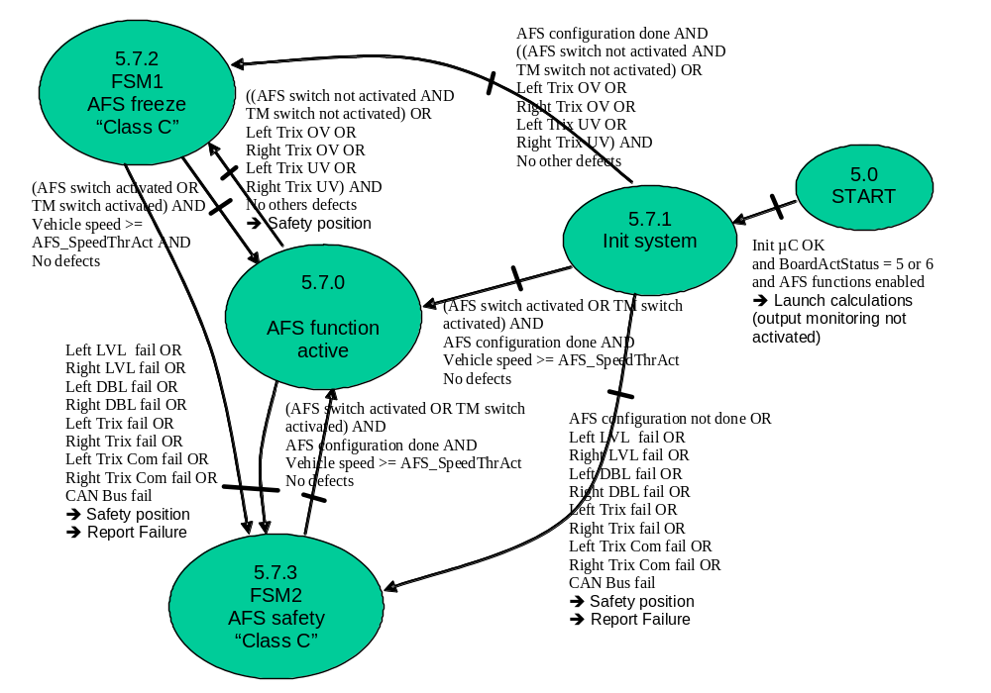

Figure 15 : AFS module “Fail safe strategy” state diagram for both sides

Operating state diagram validation plan
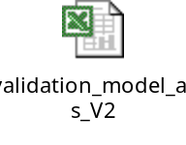

State transition synthesis chart
Req_0503_CYRS_AFS_3527-V121221
#SW
#System
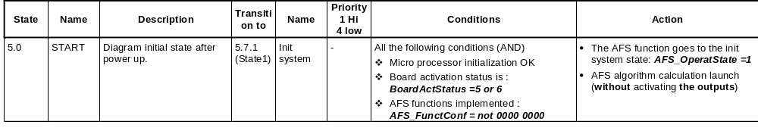
Req_0503_CYRS_AFS_4007-V121221
#SW
#System
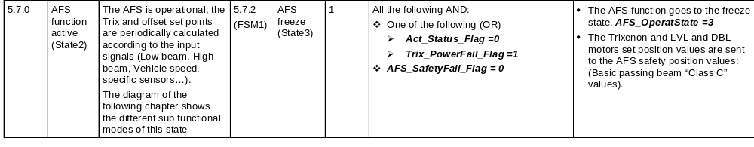
Req_0503_CYRS_AFS_3529-V121221
#SW
#System
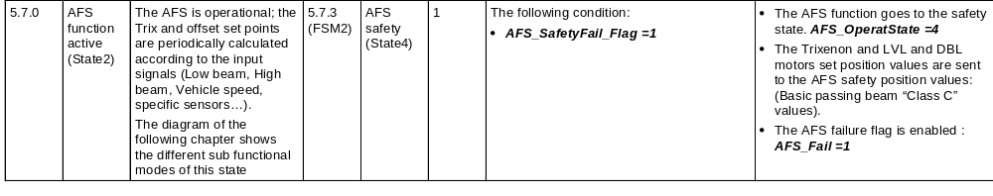
Req_0503_CYRS_AFS_3533-V121221
#SW
#System
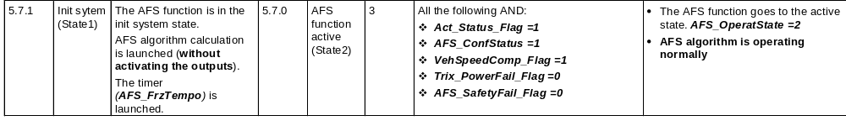
Req_0503_CYRS_AFS_4008-V121221
#SW
#System
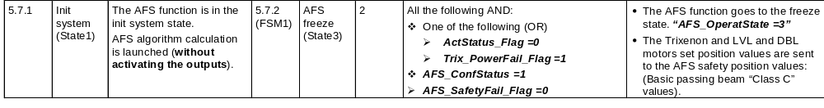
Req_0503_CYRS_AFS_3828-V121221
#SW
#System
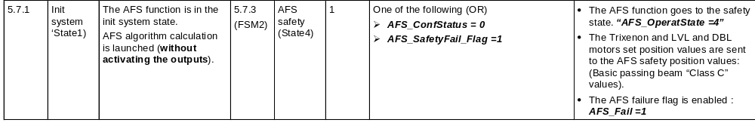
Req_0503_CYRS_AFS_3829-V121221
#SW
#System
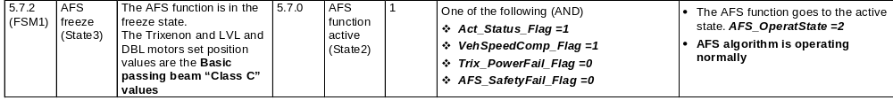
Req_0503_CYRS_AFS_4009-V121221
#SW
#System
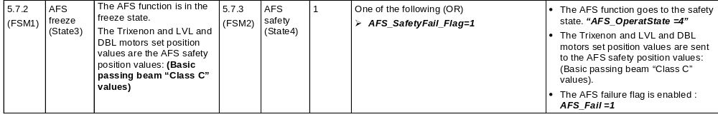
Req_0503_CYRS_AFS_4010-V121221
#SW
#System
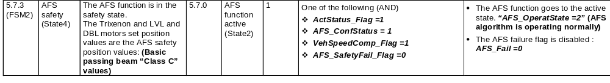
END OF DOCUMENT

